IPT 101

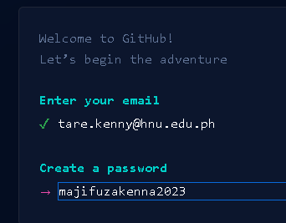

<https://www.youtube.com/watch?v=ne5ACsz-k2o>

How To Install git On Windows (and clone your first repo)